MINI PROJECT

ON

SIMPLE CALCULATOR

Project made by:

Reg no:

RA2111003011836

RA2111003011837

From Batch1: (Kishore Anthuvan sir)

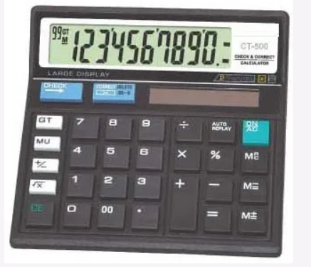

Table of contents

1.INTRODUCTION

2.BASIC FUNCTIONS

3.SYSTEM DESIGN

4. CODE

5. OUTPUT

6.APPLICATION

7.ADVANTAGES OF CALCULATOR

8.DISADVANTAGES OF CALCULATOR

# INTRODUCTION

**The most basic calculator is the four-function calculator, which can perform basic arithmetic such as addition, subtraction, multiplication and division. These are sometimes called pocket calculators or hand-held electronic calculators because they are small enough to fit in a shirt pocket.**

**BASIC FUNCTION**

Calculator Basics

- All Clear. Clears The Calculator, And Resets Any Functions. ...

- Clear Entry. Erases The Last Number Or Operation Entered.

- Addition. This Button Performs Addition.

- Minus. This Button Performs Subtraction.

- Divide. This Button Performs Division.

- Multiply. ...

- Equals. ...

- Percent Key.

SYSTEM DESIGN

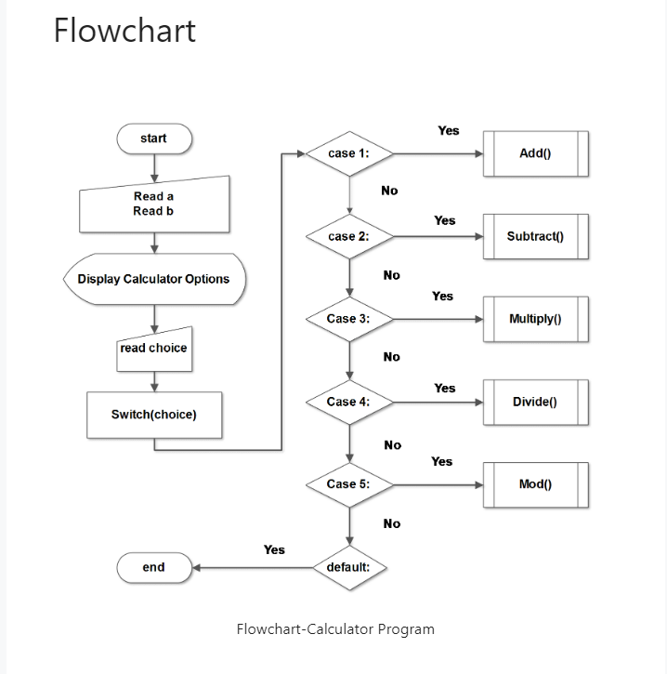

CODE

#include <stdio.h>

int main() {

char op;

double first, second;

printf("Enter an operator (+, -, *, /): ");

scanf("%c", &op);

printf("Enter two operands: ");

scanf("%lf %lf",&first,&second);

switch (op) {

case '+':

printf("%.1lf+%.1lf=%.1lf", first, second, first + second);

break;

case '-':

printf("%.1lf - %.1lf = %.1lf", first, second, first - second);

break;

case '*':

printf("%.1lf * %.1lf = %.1lf", first, second, first * second);

break;

case '/':

printf("%.1lf / %.1lf = %.1lf", first, second, first / second);

break;

printf("Error! operator is not correct");

}

return 0;

}

OUTPUT

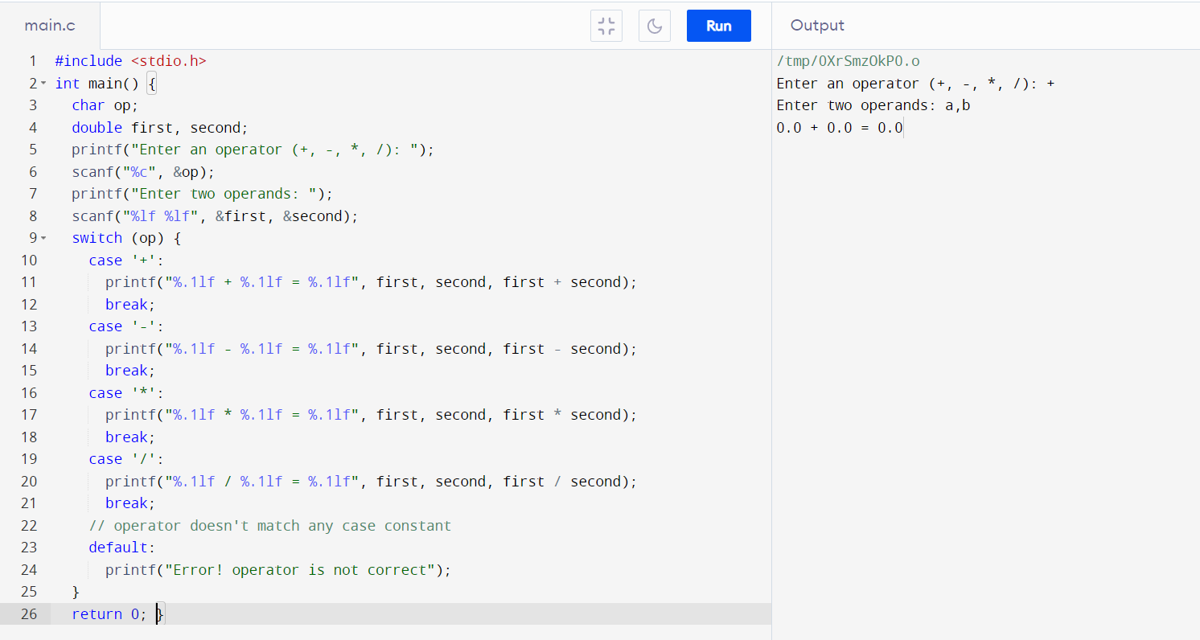

APPLICATIONS

A Calculator is an electronic hardware device or software capable of performing mathematical calculations, such as addition, multiplication, subtraction, or division. The Casio Computer Company developed the first electronic calculator in 1957.

ADVANTAGE OF CALCULATOR

This technology allows students solve complicated problems quickly and in an efficient manner. Additionally, it can reduce the problem to simpler tasks and allows the student to devote more time in understanding the problem. Secondly, they are saved from monotonous calculations and the same boring mundane procedure.

DISADVANTAGES OF CALCULATOR

Dependency. Even though calculators can do the basic operations instantly, students should not use it all the time. ...

Cheating. The availability of graphic calculators has made it easier for students to cheat during their tests. ...

High cost.



THANK

YOU

……